Support for Increased Ticket Prices: Big Mountain Resort
The Big Mountain Resort recently installed a new ski lift to help distribute riders more evenly. To offset the new operating costs, the resort first would like to know if the higher ticket prices they’ve enacted are justified, or if they need to lower prices back to market share average and find areas to cut costs or increase revenue. The critical criteria for this decision include determining if the resort is justified in raising prices based on the facilities available and determining where costs can be trimmed- or revenue increased- to offset the additional $1,540,000 in operating expenses.
To answer this question, a Random Forest model was constructed. This model uses the features of existing resorts nationwide as they relate to the resort ticket prices. The assumption with this model is that skiers will purchase 5-day passes. The model operates without Big Mountain data included, so the predicted ticket price is not influenced by the current ticket price. Further, this model can be used to determine how modifying existing features or adding/removing features will impact ticket prices.
Testing Results
The model predicted a ticket price of $95.87, which is higher than the current ticket price of $81 for an adult weekend pass. Support for this price increase includes the following features:
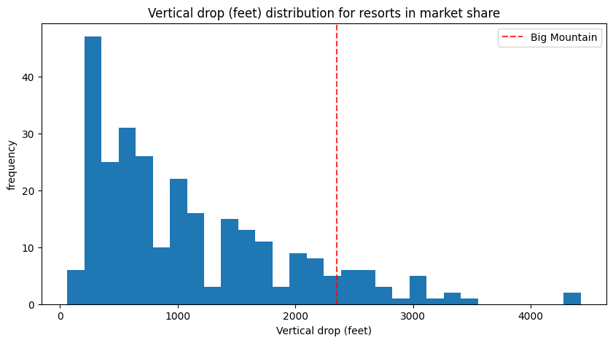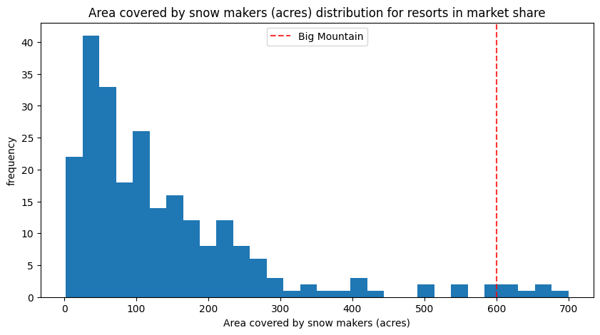
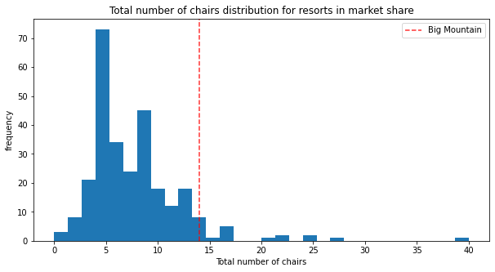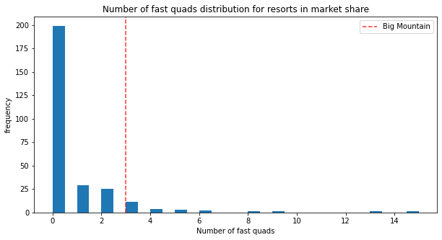
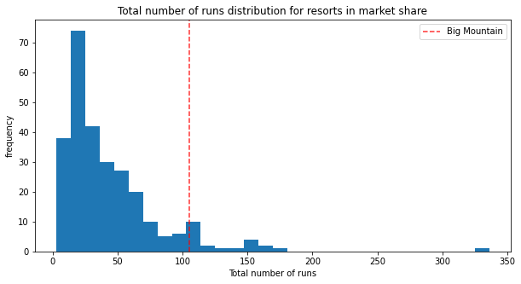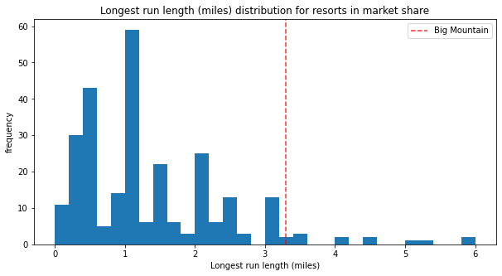
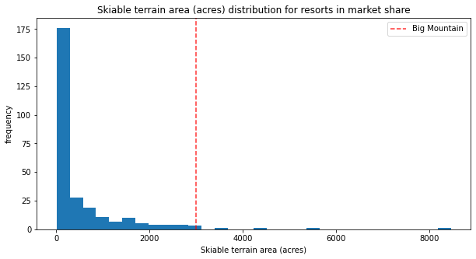
As shown in the above figures, Big Mountain resort is placed highly with all of these features, above industry standard.
Four scenarios were proposed to increase revenue or cut costs. Scenario 1 (see below) proposed closing some of the least used runs at the resort to offset the cost of the new chairlift. The model tells us that closing 1 run will not impact ticket prices, but closing 2 or more removes support for the increased ticket price.
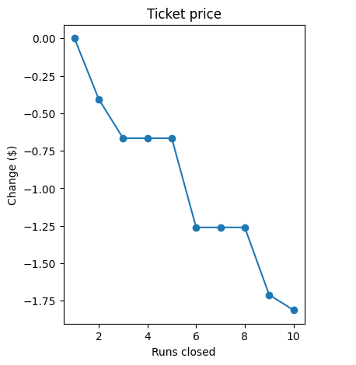
Scenario 2 proposed adding a run, a new chairlift, and increasing the vertical drop by 150 feet. This scenario shows support for an increase of $8.61 per ticket, amounting to $1506541 over the course of the season. Scenario 3 proposed that in addition to Scenario 2, 2 acres of snow-making is also added. This shows support for increasing the ticket price by an additional $1.29 which would account for an additional $2257246 over the course of the season. Scenario 4 proposed to increase the longest run by .2mi and add 4 acres of snow-making. The model does not support increased ticket prices in this scenario.
Recommendations
To offset the costs of the new chair lift, scenario 2 is the recommended course of action. This scenario accounts for the addition of a new ski lift (which has already been installed) and the addition of a new run and increased vertical drop will amass enough in additional revenue to cover the operating costs of the new ski lift. In the future, scenario 3 should also be considered- the addition of 2 acres of snow-making- because it further supports an increase in ticket prices and therefore revenue.
Next Steps
In order to determine the true profit of these scenarios, additional information is needed. To improve this analysis, the operating costs of a new run and additional vertical drop length need to be factored into this model. It would also benefit to include maintenance costs in that figure as well. Should scenario 3 be further explored, operating and maintenance for the additional snow-making area will also be needed. This model also does not take into consideration the upfront costs of implementing these new features.

